

 **PRODUCT** 

 **CATALOGUE**



Technology and Innovation to Keep Your Health



Aideaxx (Shandong) Biotech

Co., Ltd.

**<< COMPANY PROFILE**

Aideaxx (Shandong) Biotech Co., Ltd.

Aideaxx (Shandong) Biotech Co., Ltd. headquartered in Qingdao, Shandong Province, China, has been focusing on the R&D, production, sales and service of medical devices and in vitro diagnostic reagents to provide customers with professional diagnostic solutions since founded in 2010.

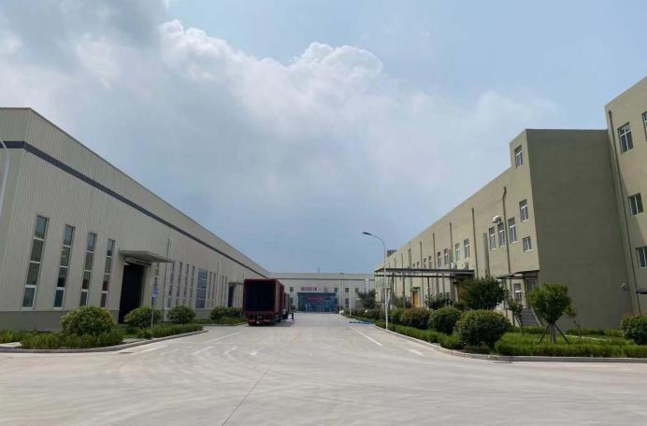

Aideaxx (Shandong) Biotech Co.,Ltd is a R&D

based manufacturer, engaged in development,

manufacturing and trading of in vitro diagnostic

reagents (IVD). Currently, we are providing

extensive ranges of POCT instant diagnostic

reagents, which are mainly used in the

detection of infectious diseases (including

COVID-19 detection products), drugs of abuse,

tumor & cardiac marker detection and animal

diseases detection.

Aideaxx has a 4A Class purification workshop with

reasonable layout under GMP standard, own full- fledged platform of immunochromatography, Elisa, PCR and antibody research, and also has a standard testing laboratory and an experimental animal center, we are committed to using our technology and innovation to improve the quality of life. Market- oriented, integrates research, production, selling and service, with high quality products and services as the core competitiveness, Aideaxx aimed to provide top quality products with effective price.

**<< CONTENT**

**COVID-19 Diagnostic Solutions**

|  |
| --- |
| **Rapid Test** |
| Fertility Tests  HCG LH FSH |
| **Infectious Diseases Tests** |
| Sexually Transmitted Disease Tests  HIV TP Chlamydia Ag |
| Hepatitis VirusTests  HBsAg HCV |
| Tropical DiseasesTests  Malaria H. Pylori Ab H. Pylori Ag Typhoid Dengue |
| Cardiac Markers Tests  Troponin I Myoglobin CK-MB |
| Tumor Markers Tests  PSA FOB CEA AFP |
| TORCH Panel Tests  TOXO RV CMV HSV |
| Respiratory Tests  Influenza Strep A RSV MP |
| Drug of Abuse Tests  THC COC AMP MET |

**COVID-19**

Diagnostic Solutions

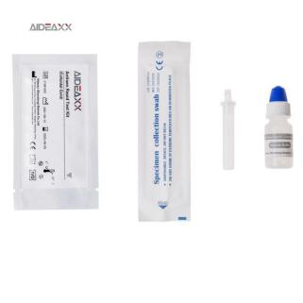

|  |  |  |  |  |  |  |
| --- | --- | --- | --- | --- | --- | --- |
| Platform Cat. No. Product Description Specimen Format Kit Size Qualification | | | | | | |
| Colloidal Gold | H100A-23W | SARS-CoV-2 IgM/IgG Antibody Rapid Test | WB/S/P | Cassette | 25/40T | CE |
| H100N-23W | SARS-CoV-2 Neutralizing Antibody Rapid Test | WB/S/P | Cassette | 25T/40T | CE |
| H100V-43W | SARS-CoV-2 Ab/Neutralizing Antibody Rapid Test | WB/S/P | Cassette | 25T | CE |
| H100D-23W | SARS-CoV-2 RBD Antibody Rapid Test | WB/S/P | Cassette | 25T | CE |
| H100DG-23W | SARS-CoV-2 RBD IgG Antibody Rapid Test | WB/S/P | Cassette | 25T | CE |
| H100G-23S | SARS-CoV-2 Antigen Rapid Test (For professionaluse) | Swab | Cassette | 1/5/25T | CE |
| H100G | SARS-CoV-2 Antigen Rapid Test(For self test) | Swab | Cassette | 1/5/25T | CE1434 |
| H100S-23B | SARS-CoV-2 Antigen Saliva Rapid Test | Saliva | Cassette | 20T | CE |
| H100C-43S | SARS-CoV-2/FLU A+B Antigen Rapid Test | Swab | Panel | 20T | CE |
| H107-43S | SARS-CoV-2/FLU A+B/RSV Antigen Rapid Test | Swab | Panel | 20T | CE |
| H108-43S | SARS-CoV-2/FLU A+B/RSV/ADVAntigen Rapid Test | Swab | Panel | 20T | CE |
| Molecular Platform |  | Nucleic acid extraction or purification kit | Swab | —— | 16/32/48T | CE |
| ELISA Platform | H366 | SARS-CoV-2 Neutralizing Antibody Test | Serum/Plasma | —— | 96/480T | CE |
| FIA Platform | H654 | SARS-CoV-2 Neutralizing Antibody Test | WB/S/P | —— | 25T | CE |





 

hcG  PregnanCY Test

C 6o 23

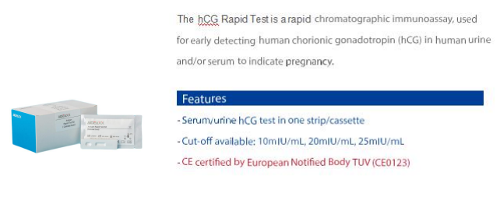



HCG Pregnancy Test

Product Description

Specimen

CE status

Cat. No.

Kit Size

Cut-Off

Format

|  |  |  |  |  |  |  |
| --- | --- | --- | --- | --- | --- | --- |
| H111-14U | hCG Pregnancy TestStrip | Urine | Strip | 50T | 10mIU/ml  25mIU/ml | CE0123,FDA |
| H111-14U | hCG Pregnancy TestStrip | Urine | Strip | 1T | CE0123,FDA |
| H111-23U | hCG PregnancyTest Cassette | Urine | Cassette | 25T | CE0123,FDA |
| H111-24U | hCG PregnancyTest Cassette | Urine | Cassette | 1T | CE0123,FDA |
| H111-35U | hCG Pregnancy TestMidstream | Urine | Midstream | 20T | CE0123,FDA |
| H111-36U | hCG Pregnancy TestMidstream | Urine | Midstream | 1T | CE0123,FDA |
| H111-37U | hCG Pregnancy WeeklyTest  Midstream | Urine | Midstream | 1T | 25mIU/ml  100mIU/ml  500mIU/ml | CE |
| H111-11P | hCG Pregnancy TestStrip | Serum | Strip | 50T | 10mIU/ml  25mIU/ml | CE |
| H111-23P | hCG PregnancyTest Cassette | Serum | Cassette | 25T | CE |
| H111-11B | hCG Pregnancy TestStrip | Urine/Serum | Strip | 50T | CE |
| H111-23B | hCG PregnancyTest Cassette | Urine/Serum | Cassette | 25T | CE |

Lh Ovulation Test

Cat. No. Product Description Specimen Format Kit Size Cut-off CE status

|  |  |  |  |  |  |  |
| --- | --- | --- | --- | --- | --- | --- |
| H112-11U | Lh Ovulation Test Strip | Urine | Strip | 50T | 10mIU/ml 25mIU/ml | CE0123 |
| H112-23U | Lh Ovulation TestCassette | Urine | Cassette | 25T | CE0123 |
| H112-35U | Lh Ovulation Test Midstream | Urine | Midstream | 20T | CE0123 |
| H112-36U | Lh Ovulation Test Midstream | Urine | Midstream | 1T | CE0123 |

FSH Menpause Test



|  |  |  |  |  |  |  |
| --- | --- | --- | --- | --- | --- | --- |
| H113-11U | FSH Menpause Test Strip | Urine | Strip | 50T | 25mIU/ml | CE |
| H113-23U | FSH Menpause TestCassette | Urine | Cassette | 25T | CE |







>> INFECTIOUS DISEASES TESTS

HIV 1/2

Sexually Transmitted Disease Tests

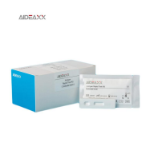

Treponema Pallidum

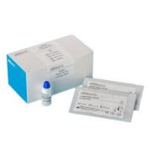

*\* Note: Both for Professional and OTC Use ( With lancet and alcohol pad)*

Sexually Transmitted Disease Tests

|  |  |  |  |  |  |  |
| --- | --- | --- | --- | --- | --- | --- |
| Cat. No. Product Description Specimen Format Kit Size Sensitivity Qualification | | | | | | |
| H131-11W | HIV 1/2 Ab Test Strip | WB/S/P | Strip | 50T | 99.70% |  |
| H131-23W | HIV 1/2 Ab TestCassette | WB/S/P | Cassette | 25T |  |
| H132-11W | HIV 1/2 Ab Test Strip (Tri-lines) | WB/S/P | Strip | 50T |  |
| H132-23W | HIV 1/2 Ab Test Cassette (Tri-lines) | WB/S/P | Cassette | 25T |  |
| H133-11W | Syphilis (TP) Ab test strip | WB/S/P | Strip | 50T | 99.40% | CE |
| H133-23W | Syphilis (TP) Ab test Cassette | WB/S/P | Cassette | 25T | CE |
| H134-11S | Gonorrhea Ag Test Strip | Swab | Strip | 50T | 98.23% | CE |
| H134-23S | Gonorrhea Ag TestCassette | Swab | Cassette | 20T | CE |
| H135-11S | Chlamydia Trachomatis Ag Test Strip | Swab | Strip | 50T | 97.55% | CE0123 |
| H135-23S | Chlamydia Trachomatis Ag Test Cassette | Swab | Cassette | 20T | CE0123 |
| H136-11W | HIV Ag/Ab Test Strip | WB/S/P | Strip | 50T | — |  |
| H136-23W | HIV Ag/Ab TestCassette | WB/S/P | Cassette | 25T | — |  |
| H137-43W | HIV/HBsAg/HCV 3-in-1 Test Panel | WB/S/P | Panel | 20T | — |  |
| H138-43W | HIV/HBsAg/HCV/Syphilis 4-in-1 Test Panel | WB/S/P | Panel | 20T | — |  |







>> INFECTIOUS DISEASES TESTS

Anti - HCV

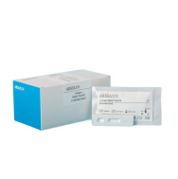

HBsAg

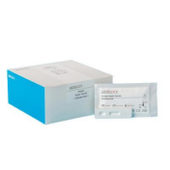

Hepatitis VirusTests

Hepatitis Virus Tests

|  |  |  |  |  |  |  |  |
| --- | --- | --- | --- | --- | --- | --- | --- |
| Cat. No. Product Description Specimen Format Sensitivity Kit Size Qualification | | | | | | | |
| H121-11WM | | HAV Hepatitis A Virus Ab IgM TestStrip | WB/S/P | Strip | 98.9% | 50T | CE |
| H121-23WM | | HAV Hepatitis A Virus Ab IgMTest Cassette | WB/S/P | Cassette | 25T | CE |
| H121-23W | | HAV Hepatitis A Virus Ab IgM/IgG Test Cassette | WB/S/P | Panel | — | 25T | — |
| H122-43W | | HBV Hepatitis B Virus 5-in-1 TestPanel | WB/S/P | Panel | 98.2% | 20T | — |
| H123-11W | | HBsAg Hepatitis B Surface Ag Test Strip | WB/S/P | Strip | 2.5ng/ml | 50T | — |
| H123-23W | | HBsAg Hepatitis B Surface Ag Test Cassette | WB/S/P | Cassette | 2.5ng/ml | 25T | — |
| H124-11W | | HBsAb Hepatitis B Surface Ab Test Strip | WB/S/P | Strip | 99.6% | 50T | — |
| H124-23W | | HBsAb Hepatitis B Surface Ab Test Cassette | WB/S/P | Cassette | 25T | — |
| H125-11W | | HBeAg Hepatitis B Envelope Ag Test Strip | WB/S/P | Strip | 99.6% | 50T | — |
| H125-23W | | HBeAg Hepatitis B Envelope Ag TestCassette | WB/S/P | Cassette | 25T | — |
| H126-11W | | HBeAb Hepatitis B Envelope Ab Test Strip | WB/S/P | Strip | 91.5% | 50T | — |
| H126-23W | | HBeAb Hepatitis B Envelope Ab Test Cassette | WB/S/P | Cassette | 25T | — |
| H127-11W |  | HBcAb Hepatitis B Core Ab Test Strip | WB/S/P | Strip | 93.5% | 50T | — |
| H127-23W | | HBcAb Hepatitis B Core Ab Test Cassette | WB/S/P | Cassette | 25T | — |
| H128-11W | | HCV Hepatitis C Virus Ab Test Strip | WB/S/P | Strip | 99.8% | 50T | — |
| H128-23W | | HCV Hepatitis C Virus AbTest Cassette | WB/S/P | Cassette | 25T | — |
| H129-11W | | HEV Hepatitis E Virus Ab IgMTest Strip | WB/S/P | Strip | 98.91% | 50T | CE |
| H129-23W | | HEV Hepatitis E Virus Ab IgM Test Cassette | WB/S/P | Cassette | 25T | CE |
| H1210 | | HBsAg/HCV TestPanel | WB/S/P | Panel | — | 20T | — |



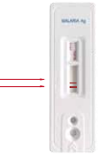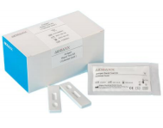

》



>> INFECTIOUS DISEASES TESTS

Malaria Antigen Test

P.v

P.f

Dengue NS1/IgM/IgG Test

Hepatitis VirusTests

|  |  |  |  |  |  |
| --- | --- | --- | --- | --- | --- |
| 人 Qualification | | | | | |
| H141-23W | Dengue Ag NS1 TestCassette | WB/S/P | Cassette | 25T | CE |
| H142-23W | Dengue Ab IgM/IgG Test Cassette | WB/S/P | Cassette | 25T | CE |
| H143-43W | Dengue NS1/IgM/IgG TestPanel | WB/S/P | Panel | 20T | CE |
| H144-11W | H.Pylori Ab Test Strip | WB/S/P | Strip | 50T | CE |
| H144-23W | H.Pylori Ab TestCassette | WB/S/P | Cassette | 25T | CE |
| H145-11F | H.Pylori Ag Test Strip | Feces | Strip | 20T | CE |
| H145-23F | H.Pylori Ag TestCassette | Feces | Cassette | 20T | CE |
| H146-11W | Malaria P.f.Ag Test Strip | Whole Blood | Strip | 50T | CE |
| H146-23W | Malaria P.f.Ag Test Cassette | Whole Blood | Cassette | 25T | CE |
| H147-11W | Malaria P.v. Ag TestStrip | Whole Blood | Strip | 50T | CE |
| H147-23W | Malaria P.v.Ag Test Cassette | Whole Blood | Cassette | 25T | CE |
| H148-11W | Malaria Pan Ag Test Strip | Whole Blood | Strip | 50T |  |
| H148-23W | Malaria Pan Ag Test Cassette | Whole Blood | Cassette | 25T |  |
| H149-11W | Malaria P.f./P.v. Ag Test Strip | Whole Blood | Strip | 50T | CE |
| H149-23W | Malaria P.f./P.v. Ag TestCassette | Whole Blood | Cassette | 25T | CE |
| H1410-11W | Malaria P.f./PanAg Test Strip | Whole Blood | Strip | 50T | CE |
| H1410-23W | Malaria P.f./PanAg Test Cassette | Whole Blood | Cassette | 25T | CE |
| H1411-23W | Typhoid Ab IgM/IgG Test Cassette | WB/S/P | Cassette | 25T | CE |
| H1413-23P | Chikungunya Ab IgM Test Cassette | S/P | Cassette | 25T | CE |
| H1414-23F | Cholera Ag O1 Rapid TestCassette | Feces | Cassette | 20T | CE |
| H1415-23F | Cholera Ag O139 Rapid TestCassette | Feces | Cassette | 20T |  |
| H1417-23P | Leishmania Ab IgM/IgG Test Cassette | S/P | Cassette | 25T | CE |
| H1418-23P | Leptospira Ab IgM/IgG Test Cassette | S/P | Cassette | 25T | CE |
| H1419-11F | Adenovirus Ag Test Strip | Feces | Strip | 20T | CE |
| H1419-23F | Adenovirus Ag TestCassette | Feces | Cassette | 20T | CE |





>> INFECTIOUS DISEASES TESTS

 Qualification

|  |  |  |  |  |  |
| --- | --- | --- | --- | --- | --- |
| H1420-11F | Rotavirus Ag Test Strip | Feces | Strip | 20T | CE |
| H1420-23F | Rotavirus Ag TestCassette | Feces | Cassette | 20T | CE |
| H1421-43F | Adenovirus/Rotavirus AgTest Panel | Feces | Panel | 20T | CE |
| H1422-23F | Salmonella Typhi AgTest Cassette | Feces | Cassette | 20T | CE |
| H1423-11W | C-Reactive Protein Semi-Quantitative Test Strip | WB/S/P | Strip | 50T | CE |
| H1423-23W | C-Reactive Protein Semi-Quantitative Test Cassette | WB/S/P | Cassette | 25T | CE |
| H1424-11W | Anti-cyclic citrullinated peptide (CCP) antibody detection Test Strip | WB/S/P | Strip | 50T |  |
| H1424-23W | Anti-cyclic citrullinated peptide (CCP) antibody detection Test Cassette | WB/S/P | Cassette | 25T |  |
| H1425-11WG | TB Tuberculosis Ab IgG Test Strip | WB/S/P | Strip | 50T | CE |
| H1425-23WG | TB Tuberculosis Ab IgG TestCassette | WB/S/P | Cassette | 25T | CE |

Malaria P.f. /P.v.Ag Test

|  |  |  |  |
| --- | --- | --- | --- |
|  |  |  |  |
| Malaria P.f./P.v.Ag Test | Test Cassette | Buffer | Dropper |

Typhoid G/M Ab Test

|  |  |  |  |
| --- | --- | --- | --- |
|  |  |  |  |
| Typhoid G/M Ab Test | Test Cassette | Buffer | Dropper |

H. Pylori Ag Test

|  |  |  |
| --- | --- | --- |
|  |  |  |
| H. Pylori Ag Test | Test Cassette | Sample Tube |

Dengue NS1/G/M Test

|  |  |  |  |
| --- | --- | --- | --- |
|  |  |  |  |
| Dengue NS1/G/M Test | Test Cassette | Buffer | Dropper |

9





 

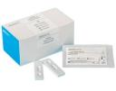

Troponin ITest



Myoglobin Test



CK-MB Test

|  |  |  |  |  |  |  |
| --- | --- | --- | --- | --- | --- | --- |
| Cut-off Qualification | | | | | | |
| H161-11W | cTnI Troponin I TestStrip | WB/S/P | Strip | 50T | 1ng/ml | CE |
| H161-23W | cTnI Troponin ITest Cassette | WB/S/P | Cassette | 25T | 1ng/ml | CE |
| H162-11W | MYO Myoglobin Test Strip | WB/S/P | Strip | 50T | 80ng/ml | CE |
| H162-23W | MYO Myoglobin Test Cassette | WB/S/P | Cassette | 25T | 80ng/ml | CE |
| H163-11W | CK-MB Creative Kinase-MB Test Strip | WB/S/P | Strip | 50T | 5ng/ml | CE |
| H163-23W | CK-MB Creative Kinase-MB Test Cassette | WB/S/P | Cassette | 25T | 5ng/ml | CE |
| H164-43W | CTNI/MYO/CK-MB TestPanel | WB/S/P | Panel | 20T | —— | CE |

>> TUMOR RS 

C 60 23



PSATest



FOBTest



CEATest

|  |  |  |  |  |  |  |
| --- | --- | --- | --- | --- | --- | --- |
| Cut-off Qualification | | | | | | |
| H171-11P | AFP Alpha Fetoprotein TestStrip | S/P | Strip | 50T | 20ng/ml | CE |
| H171-23P | AFP Alpha FetoproteinTest Cassette | S/P | Cassette | 25T | 20ng/ml | CE |
| H172-11P | CEA Carcinoma Embryonic Ag TestStrip | S/P | Strip | 50T | 5ng/ml | CE |
| H172-23P | CEA Carcinoma Embryonic Ag TestCassette | S/P | Cassette | 25T | 5ng/ml | CE |
| H173-11F | FOB Fecal Occult Blood Test Strip | Feces | Strip | 20T | 50ng/ml | CE |
| H173-23F | FOB Fecal Occult Blood Test Cassette | Feces | Cassette | 20T | 50ng/ml | CE |
| H174-11P | PSA Prostate Specific Ag Test Strip | S/P | Strip | 50T | 4ng/ml | CE0123 |
| H174-23P | PSA Prostate Specific Ag TestCassette | S/P | Cassette | 25T | 4ng/ml | CE0123 |
| H175-43P | AFP/CEA/PSATestPanel | S/P | Panel | 20T |  |  |
| H176-23F | TFTransferrinTestCassette | Feces | Cassette | 25T | 40ng/ml | CE |
| H177-43F | FOB/TFTestPanel | Feces | Cassette | 20T |  |  |
| H178-43F | Hemoglobin (Hb)/Transferrin (TF)TestPanel | Feces | Panel | 20T |  | CE |



**RAPID TESTS**

>> TORCH PANEL

The first company around the word to obtain CE certificate for TORCH rapid test .

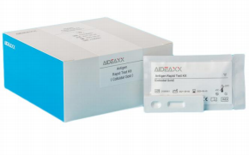

UNIQUE FEATURES

Multiplex POCT design

- 5 tests in 1 panel

- 1 test procedure for 10 parameter results

- detection and differentiation of both IgM and IgG in all 5 tests

Differentiate HSV-1 and HSV-2

Whole blood compatible

Allows for testing in various settings, such as

- emergency

- physician office without centrifuge

- remote area without skilled lab technicians and stable electricity

Specimen Format Kit size CE status

Cat. No.

Product Description

|  |  |  |  |  |  |
| --- | --- | --- | --- | --- | --- |
| H181-23WM | TOXO Toxoplasma Ab IgM Test Cassette | WB/S/P | Cassette | 25 T | CE 0123 |
| H181-23WG | TOXO Toxoplasma Ab IgG Test Cassette | WB/S/P | Cassette | 25 T | CE 0123 |
| H181-23W | TOXO Toxoplasma Ab IgM/IgG Test Cassette | WB/S/P | Cassette | 25 T | CE 0123 |
| H182-23WM | RV Rubella Ab IgM Test Cassette | WB/S/P | Cassette | 25 T | CE 0123 |
| H182-23WG | RV Rubella Ab IgG Test Cassette | WB/S/P | Cassette | 25 T | CE 0123 |
| H182-23W | RV Rubella Ab IgM/IgG Test Cassette | WB/S/P | Cassette | 25 T | CE 0123 |
| H183-23WM | CMV Cytomegalovirus Ab IgM Test Cassette | WB/S/P | Cassette | 25 T | CE 0123 |
| H183-23WG | CMV Cytomegalovirus Ab IgG Test Cassette | WB/S/P | Cassette | 25 T | CE 0123 |
| H183-23W | CMV Cytomegalovirus Ab IgM/IgG Test Cassette | WB/S/P | Cassette | 25 T | CE 0123 |
| H184-23WM | HSV-I Herpes Simplex Virus I Ab IgM Test Cassette | WB/S/P | Cassette | 25 T | CE |
| H184-23WG | HSV-I Herpes Simplex Virus I Ab IgG Test Cassette | WB/S/P | Cassette | 25 T | CE |
| H184-23W | HSV-I Herpes Simplex Virus I Ab IgM/IgG Test Cassette | WB/S/P | Cassette | 25 T | CE |
| H185-23WM | HSV-II Herpes Simplex Virus II Ab IgM Test Cassette | WB/S/P | Cassette | 25 T | CE |
| H185-23WG | HSV-II Herpes Simplex Virus II Ab IgG Test Cassette | WB/S/P | Cassette | 25 T | CE |
| H185-23W | HSV-II Herpes Simplex Virus II Ab IgM/IgG Test Cassette | WB/S/P | Cassettel | 25 T | CE |
| H186-43WM | TORCH 5-in-1 Ab IgM Test Panel | WB/S/P | Panel | 20 T |  |
| H186-43WG | TORCH 5-in-1 Ab IgG Test Panel | WB/S/P | Panel | 20 T |  |
| H186-43W | TORCH 10-in-1 Ab IgM/IgG Test Panel | WB/S/P | Panel | 20 T |  |



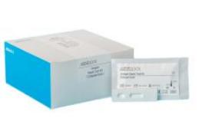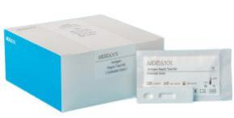



 

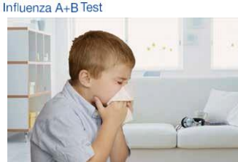

|  |  |  |  |  |  |
| --- | --- | --- | --- | --- | --- |
| Qualification | | | | | |
| H191-43S | Influenza A+B Ag Test Panel | Swab | Cassette | 20T | CE |
| H191-23S | Influenza A/BAg Test Cassette (Tri-lines) | Swab | Cassette | 25T | CE |
| H192-23S | Strep A Ag Test Cassette | Swab | Cassette | 25T | CE |
| H193-23S | ADV Respiratory Adenovirus Ag Test Cassette | Swab | Cassette | 25T |  |
| H194-23S | RSV Respiratory Syncytial Virus Ag TestCassette | Swab | Cassette | 25T |  |
| H195-43S | ADV/RSV Ag 2-in-1 Test Panel | Swab | Panel | 20T |  |
| H196-43S | Influ A+B/ADV/RSV Ag 4-in-1 Test Panel | Swab | Panel | 20T |  |
| H197-23WM | MP Mycoplasma Pneumoniae Ab IgM Test Cassette | WB/S/P | Cassette | 25T |  |
| H197-23WG | MP Mycoplasma Pneumoniae Ab IgG Test Cassette | WB/S/P | Cassette | 25T |  |
| H197-43W | MP Mycoplasma Pneumoniae Ab IgMIgG Test Panel | WB/S/P | Panel | 25T |  |
| H198-23S | MP Mycoplasma Pneumoniae Ag Test Cassette | Swab | Cassette | 25T |  |
| H199-23WM | CPn Chlamydia Pneumoniae Ab IgM Test Cassette | WB/S/P | Cassette | 25T |  |
| H199-23WG | CPn Chlamydia Pneumoniae Ab IgG Test Cassette | WB/S/P | Cassette | 25T |  |

>> OTHER RAPID 



|  |
| --- |
| Alcohol  mg/dL  Negative 20 40 80 300  **Evaluation Colour Chart** |



|  |  |  |  |  |
| --- | --- | --- | --- | --- |
| H001-11B | Alcohol Screening Test Strip | Saliva | Strip | 50T |
| H001-23B | Alcohol Screening Test Cassette | Saliva | Cassette | 25T |
| H001-11U | Alcohol Screening Test Strip | Urine | Strip | 50T |
| H001-23U | Alcohol Screening Test Cassette | Urine | Cassette | 25T |
| H002-11P | Serum Cholinesterase Test Strip | Serum | Strip | 50T |



**RAPID TESTS**

>> DRUG OF ABUSE TESTS

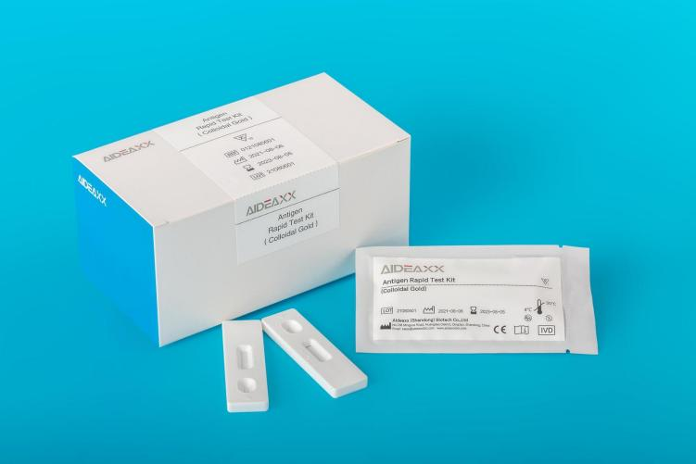

Cat. No. Product Description Specimen Format Kit size Cut-Off CE status

|  |  |  |  |  |  |  |
| --- | --- | --- | --- | --- | --- | --- |
| H151-11U | AMP Amphetamine Test Strip | Urine | Strip | 50T | 1000 ng/mL,500ng/ mL,300ng/mL | CE |
| H151-23U | AMP Amphetamine Test Cassette | Urine | Cassette | 25T | 1000 ng/mL,500ng/mL,300ng/mL | CE |
| H152-11U | BAR Barbiturate Test Strip | Urine | Strip | 50T | 300 ng/mL | CE |
| H152-23U | BAR Barbiturate Test Cassette | Urine | Cassette | 25T | 300 ng/mL | CE |
| H153-11U | BUP Buprenorphine Test Strip | Urine | Strip | 50T | 10 ng/mL | CE |
| H153-23U | BUP Buprenorphine Test Cassette | Urine | Cassette | 25T | 10 ng/mL | CE |
| H154-11U | BZO Benzodiazepines Test Strip | Urine | Strip | 50T | 300 ng/mL,200ng/mL | CE |
| H154-23U | BZO Benzodiazepines Test Cassette | Urine | Cassette | 25T | 300 ng/mL,200ng/mL | CE |
| H155-11U | COC Cocaine Test Strip | Urine | Strip | 50T | 300 ng/mL, 150ng/mL | CE |
| H155-23U | COC Cocaine Test Cassette | Urine | Cassette | 25T | 300 ng/mL, 150ng/mL | CE |
| H156-11U | COT Cotinine Test Strip | Urine | Strip | 50T | 200 ng/mL | CE |
| H156-23U | COT Cotinine Test Cassette | Urine | Cassette | 25T | 200 ng/mL | CE |



|  |  |  |  |  |  |  |
| --- | --- | --- | --- | --- | --- | --- |
| Cat. No. Product Description Specimen Format Kit size Cut-Off CE status | | | | | | |
| H157-11U | EDDP Ethylenediamine-  dimethylphosphinic acid Test Strip | Urine | Strip | 50T | 300 ng/mL | CE |
| H157-23U | EDDP Ethylenediamine-  dimethylphosphinic acid Test Cassette | Urine | Cassette | 25T | 300 ng/mL | CE |
| H158-11U | KET KetamineTest Strip | Urine | Strip | 50T | 1000 ng/mL,500ng/mL | CE |
| H158-23U | KET KetamineTest Cassette | Urine | Cassette | 25T | 1000 ng/mL,500ng/mL | CE |
| H159-11U | MDMA Ecstasy Test Strip | Urine | Strip | 50T | 1000ng/mL,500 ng/mL | CE |
| H159-23U | MDMA Ecstasy Test Cassette | Urine | Cassette | 25T | 1000ng/mL,500 ng/mL | CE |
| H1510-11U | MET Methamphetamine Test Strip | Urine | Strip | 50T | 1000ng/mL,500 ng/mL | CE |
| H1510-23U | MET Methamphetamine Test Cassette | Urine | Cassette | 25T | 1000ng/mL,500 ng/mL | CE |
| H1511-11U | MOP Morphine Test Strip | Urine | Strip | 50T | 1000ng/mL,500 ng/mL | CE |
| H1511-23U | MOP Morphine Test Cassette | Urine | Cassette | 25T | 300 ng/mL,100ng/mL | CE |
| H1512-11U | MTD Methadone Test Strip | Urine | Strip | 50T | 300 ng/mL,200ng/mL | CE |
| H1512-23U | MTD Methadone Test Cassette | Urine | Cassette | 25T | 300 ng/mL,200ng/mL | CE |
| H1513-11U | OPI Opiates Test Strip | Urine | Strip | 50T | 2000 ng/mL | CE |
| H1513-23U | OPI Opiates Test Cassette | Urine | Cassette | 25T | 2000 ng/mL | CE |
| H1514-11U | OXY Oxycodone Test Strip | Urine | Strip | 50T | 300ng/mL, 100 ng/mL | CE |
| H1514-23U | OXY Oxycodone Test Cassette | Urine | Cassette | 25T | 300ng/mL, 100 ng/mL | CE |
| H1515-11U | PCP Phencyclidine Test Strip | Urine | Strip | 50T | 25 ng/mL, 10ng/mL | CE |
| H1515-23U | PCP Phencyclidine Test Cassette | Urine | Cassette | 25T | 25 ng/mL, 10ng/mL | CE |
| H1516-11U | PPX Propoxyphene Test Strip | Urine | Strip | 50T | 300 ng/mL, 100ng/mL | CE |
| H1516-23U | PPX Propoxyphene Test Cassette | Urine | Cassette | 25T | 300 ng/mL, 100ng/mL | CE |
| H1517-11U | K2 Synthetic Marijuana Test Strip | Urine | Strip | 50T | 50 ng/mL | CE |
| H1517-23U | K2 Synthetic Marijuana Test Cassette | Urine | Cassette | 25T | 50 ng/mL | CE |
| H1518-11U | TCA Tricyclic Antidepressants Test Strip | Urine | Strip | 50T | 1000 ng/mL,500ng/mL | CE |
| H1518-23U | TCA Tricyclic Antidepressants Test Cassette | Urine | Cassette | 25T | 1000 ng/mL,500ng/mL | CE |
| H1519-11U | THC Marijuana Test Strip | Urine | Strip | 50T | 50 ng/mL | CE |
| H1519-23U | THC Marijuana Test Cassette | Urine | Cassette | 25T | 50 ng/mL | CE |
| H1520-11U | TML Tramadol Test Strip | Urine | Strip | 50T | 300 ng/mL,200ng/mL | CE |
| H1520-23U | TML Tramadol Test Cassette | Urine | Cassette | 25T | 300 ng/mL,200ng/mL | CE |
| H1524-11U | FYL Fentanyl Test Strip | Urine | Strip | 50T | 200ng/mL | CE |
| H1524-23U | FYL Fentanyl Test Cassette | Urine | Cassette | 25T | 200ng/mL | CE |
| H1521-53U | Multi-Drug Test Panel(2 - 12 Para) | Urine | Panel | 20T | — | — |
| H1522-67U | Multi-Drug Test Cup (5-16 Para) | Urine | L-Cup | 1T | — | — |
| H1523-67U | Multi-Drug Test Cup (5-16 Para) | Urine | Key-Cup | 1T | — | — |



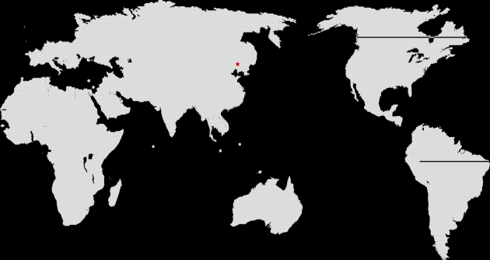QINGDAO









Aideaxx (Shandong) Biotech Co., Ltd.

Tel: 0086-532-84129977

Fax: 0086-532-84129977

E- mail: [sales@](mailto:sales@hightopbio.com)aideaxxbio .com

NO.788 Mingyue Road , Huangdao District , Qingdao , Shandong , China